Water Bottle Rocket Design Contest

Calculation Exercises

Elementary School Division

3rd – 5th Grade

1. The Skywalker team constructed a water bottle rocket and used the materials hidden in the word search below. Help your team figure out the list by finding the words.

|  |  |  |  |  |  |  |  |  |  |  |  |  |  |  |
| --- | --- | --- | --- | --- | --- | --- | --- | --- | --- | --- | --- | --- | --- | --- |
| S | J | S | G | J | A | V | B | T | X | H | M | D | A | M |
| U | V | O | L | F | E | X | E | H | T | A | S | O | V | L |
| J | W | D | J | L | T | T | X | E | Y | C | P | U | B | C |
| B | A | A | S | V | E | A | V | R | I | G | H | T | O | G |
| O | A | Q | C | J | K | H | R | S | M | J | H | R | X | Y |
| B | W | N | I | U | C | B | S | B | F | T | R | A | C | K |
| L | O | D | E | N | O | O | N | G | X | U | B | L | O | L |
| H | X | N | P | A | R | T | Y | M | G | M | O | U | X | F |
| I | G | L | R | S | Z | T | T | A | P | E | A | G | I | J |
| R | T | D | Y | N | W | L | T | L | E | E | F | N | Y | E |
| V | O | D | L | I | T | E | R | K | U | U | L | A | S | P |
| S | U | G | F | Z | D | T | N | J | C | X | T | I | W | D |
| M | I | N | G | G | Y | C | S | T | E | O | C | R | N | K |
| R | T | V | U | R | M | Q | R | J | M | O | E | T | W | O |
| H | Q | K | X | K | V | V | D | O | S | A | E | X | S | C |

Word List

|  |  |  |
| --- | --- | --- |
| BOARD | HAT | SODA |
| BOTTLE | LITER | TAPE |
| BOX | PARTY | TRIANGULAR |
| CORRUGATED | RIGHT | TWO |
| EGGSHELLS | ROCKET |  |
| FIN | SCISSORS |  |

Use the data table below to answer questions 2 and 3.



|  |  |  |
| --- | --- | --- |
| Rocket | Weight (kg) | Height (cm) |
| A | 100 | 125 |
| B | 25 | 65 |
| C | 15 | 25 |
| D | 125 | 100 |
| E | 80 | 85 |

1. List the five rockets from lightest to heaviest. Use the data in the table above.

|  |  |  |  |  |  |
| --- | --- | --- | --- | --- | --- |
| Rocket  (Letter) |  |  |  |  |  |
| Weight (kg) |  |  |  |  |  |

1. List the five rockets above from tallest to shortest. Use the data in the table above.

|  |  |  |  |  |  |
| --- | --- | --- | --- | --- | --- |
| Rocket  (Letter) |  |  |  |  |  |
| Height (cm) |  |  |  |  |  |

**Question 4 Example:**

The **distance** **around a circle** is known as the **circumference**. The **diameter** is the **distance across the circle**, which goes through the circle's center.

The example below shows the circle circumference is **44 cm**, and the diameter is **14 cm**.



1. What is the circumference and diameter of the circle below?



Circumference = ____ cm

Diameter = ____ cm

**Question 5 Example:**

The equation for the circumference of a circle is:

**𝑪 = 𝝅 × 𝑫**

**𝑪** is the circumference of a circle.

**𝜋** is the Greek symbol pi and is constant equal to 22/7≈ 3.14

**𝐷** is the diameter of the circle.

**Example A:**

A circle has a diameter of 5 cm. What is the circumference of the circle?

**𝐶 = 𝜋 × 𝐷**

**𝐶 = 𝜋 × (5 𝑐𝑚)**

**𝐶 = (3.14 × 5 𝑐𝑚)**

**𝐶 = 16 𝑐𝑚**

1. What is the circumference and diameter of the circle below?

(Use 3.14 for the value of **𝜋)**



Diameter = ____ cm

Circumference = ____ cm

**Question 6 Examples:**

A **triangle** is a shape that has three sides and three angles that add up to **180 degrees**. A **right triangle** is a type of triangle that has one angle that is **90 degrees**. The fins on the water bottle rockets are made of triangles. These fins help keep the rocket on track and stop it from spinning in the air.

Below are two right triangles with the bases and heights labeled. Notice that the height is the "up and down" measurement and that the base is the "across" measurement.

|  |  |
| --- | --- |
| **Example 1:** The height of the triangle below is **10 cm,** and the base is **6 cm**.   | **Example 2:** The base of the triangle is **4 cm,** and the height of the triangle is **7 cm**. |

1. What are the heights and the bases of the right triangular fins below?

A)  B) 

Height = ____ cm Height = ____ cm

Base = ____ cm Base = ____ cm

**Question 7 Examples:**

The perimeter of a figure is the total distance around a shape; in other words, it is the sum of the lengths of the sides of a shape.

The equation for the perimeter of a triangle is the following:

|  |  |
| --- | --- |
| 𝑷 = 𝒂 + 𝒃 + 𝒄  a = side length  b = side length  c = side length |  |

**Example A:** What is the perimeter of the triangle?

|  |  |
| --- | --- |
| P = a + b + c  P = 8 cm + 8 cm + 4 cm  P = 20 cm |  |

**Example B:** What is the perimeter of the right triangle?

|  |  |
| --- | --- |
| P = a + b + c  P = 3 cm + 5 cm + 4 cm  P = 12 cm |  |

1. What are the perimeters of the two right triangle fins below?

A)  B)

Perimeter = ____ cm Perimeter = ____ cm

**Question 8 Examples:**

The **area** of a shape is the space within or enclosed by the perimeter of a shape. The area of a triangle is the space between sides a, b, and c, shaded blue in the triangle below.



We can calculate the area of a triangle using this formula:



|  |  |
| --- | --- |
|  | b = base of the triangle  h = height of the triangle |

**Example A:** What is the area of the triangle fin?

|  |  |
| --- | --- |
|  | A = ½ (4 cm) X 6 cm  A = 12 cm2 |

**Example B:** What is the area of the triangle fin?

|  |  |
| --- | --- |
|  | A = ½ (5 cm) X 10 cm  A = 25 cm2 |
|  |  |

1. Calculate the area for each of the fins below and compare.

A)  B) 

Area = ____ cm2 Area = ____ cm2

**Question 9 Examples:**

**MEAN**

The mean is the average value of the number set, or the "central" value of the number set ("How to Find the Mean," 2020).

How to Find the Mean. (n.d.). Retrieved November 21, 2020, from <https://www.mathsisfun.com/mean.html>

To find the **mean** of set of numbers, follow these steps:

1. Add up all the values (the numbers) in the number set to find the **sum** or **total** of the number set.
2. **Count** the number of **values** in the number set.
3. Divide the sum (or total) calculated in Step A by the number of values counted in Step B to calculate the **mean**.

**Example A:** What is the mean of this number set? 9, 13, 1, 15, 8, 4, 6

Step A: Find the sum of the number set. Sum = 9 + 13 + 1 + 15 + 8 + 4 + 6

Sum = 56

Step B: Count the number of values in the number set. Number of Values = 7

Step C: Divide the Sum by the Number of Values. Mean = 56/7 **Mean** = 8

**MEDIAN**

The median is the middle number of a set of numbers ("How to Find the Median Value," 2020).

How to Find the Median. (n.d.). Retrieved November 21, 2020, from <https://www.mathsisfun.com/median.html>

To find the **median** follow these steps:

1. Rearrange the numbers in the number set to be in numerical order from least to greatest
2. Find the number that is in the middle of the number set. Do this by crossing off 1 number from each end until you get to the middle of the number set.
   1. If you have a number set with an even number of numbers, complete Step B until you get to the last 2 numbers in the middle. Calculate the B of the two middle numbers to find the median.

**Example A:** What is the median of this number set? 9, 13, 1, 15, 8, 4, 6

Step A: Rearrange from lowest to highest: 1, 4, 6, 8, 9, 13, 15

Step B: Cross off numbers from each end to find the middle: ~~1, 4, 6~~, 8, ~~9, 13, 15~~

**Median** = 8

**Example B:** What is the median of this number set? 21, 9, 13, 1, 15, 8, 4, 6

Step A: Rearrange from lowest to highest: 1, 4, 6, 8, 9, 13, 15, 21

Step B: Cross off numbers from each end to find the middle: ~~1, 4, 6,~~ 8, 9, ~~13, 15, 21~~

Step B(a): Find the mean between the two middle numbers: **Median** =

**MODE**

The mode is the number that appears most often(frequent) in the number set ("How to Find the Mode or Modal Value," 2020). A number set having two modes is called "bimodal," and a number set having more than two modes is called "multimodal."

How to Find the Mode. (n.d.). Retrieved November 21, 2020, from <https://www.mathsisfun.com/mode.html>

To find the **mode** follow these steps:

1. Put the numbers in numerical order from least to greatest.
2. Count the number of times each number appears in the number set.
3. The number that appears the most is the **mode**.

**Example A:** What is the mode of the number set? 9, 15, 13, 1, 15, 8, 4, 15, 8

Step A: Rearrange from lowest to highest: 1, 4, 8, 8, 9, 13, 15, 15, 15

Step B: Count the number of times each number appears:

1 Time: 1, 4, 9, 13 2 Times: 8 3 Times: 15

Step C: Number repeated the most is the mode: **Mode** = 15

**Example 2:** What is the mode of the number set? 1, 9, 15, 13, 1, 15, 8, 4, 15, 1

Step A: Rearrange from lowest to highest: 1, 1, 1, 4, 8, 9, 13, 15, 15, 15

Step B: Count the number of times each number appears:

1 Time: 4, 8, 9, 13 3 Times: 1, 15

Step C: Number repeated the most is the mode: **Modes** = 1 & 15

**RANGE**

The range is the difference between the lowest and highest values ("The Range (Statistics)," 2020).

The Range (Statistics). (n.d.). Retrieved November 21, 2020, from <https://www.mathsisfun.com/data/range.html>

To find the **range** follow these steps:

1. Put the numbers in numerical order from least to greatest.
2. Subtract the smallest number in the number set from the largest number in the data set.

**Example A:** What is the range of this number set? 9, 13, 1, 15, 8, 4, 15

Step A: Rearrange from lowest to highest: 1, 4, 8, 9, 13, 15, 15

Step B: Subtract the smallest number from the largest: Range = 15 – 1

**Range** = 14

1. The hangtime is the amount of time the water bottle rocket stays in the air before landing. The hangtimes of five water bottle rockets are listed below.

|  |  |
| --- | --- |
| Rocket | Hangtime (seconds) |
| A | 7 |
| B | 5 |
| C | 9 |
| D | 5 |
| E | 11 |

Determine the following using the data in the chart above. Reference the previous examples for help.

1. Longest hangtime = ____ seconds, Rocket ____
2. Shortest hangtime = ____ seconds, Rocket ____
3. Mean hangtime = ____ seconds, Rocket ____
4. Median hangtime = ____ seconds, Rocket ____
5. Mode hangtime = ____ seconds, Rocket ____
6. Range of hangtimes = ____ seconds
7. Construct a bar graph to illustrate hangtimes in problem 9 with the space provided for each water bottle rocket using the same colors below the name of each Rocket.

|  |  |
| --- | --- |
| Rocket | Hangtime (seconds) |
| A | 7 |
| B | 5 |
| C | 9 |
| D | 5 |
| E | 11 |



1. Examine the rulers below. Note that one side measures centimeters, part of the metric system, and the other side measures in inches, part of the imperial system commonly used in the United States.

It is important to know how to take measurements using both systems and how to convert measurements between them.

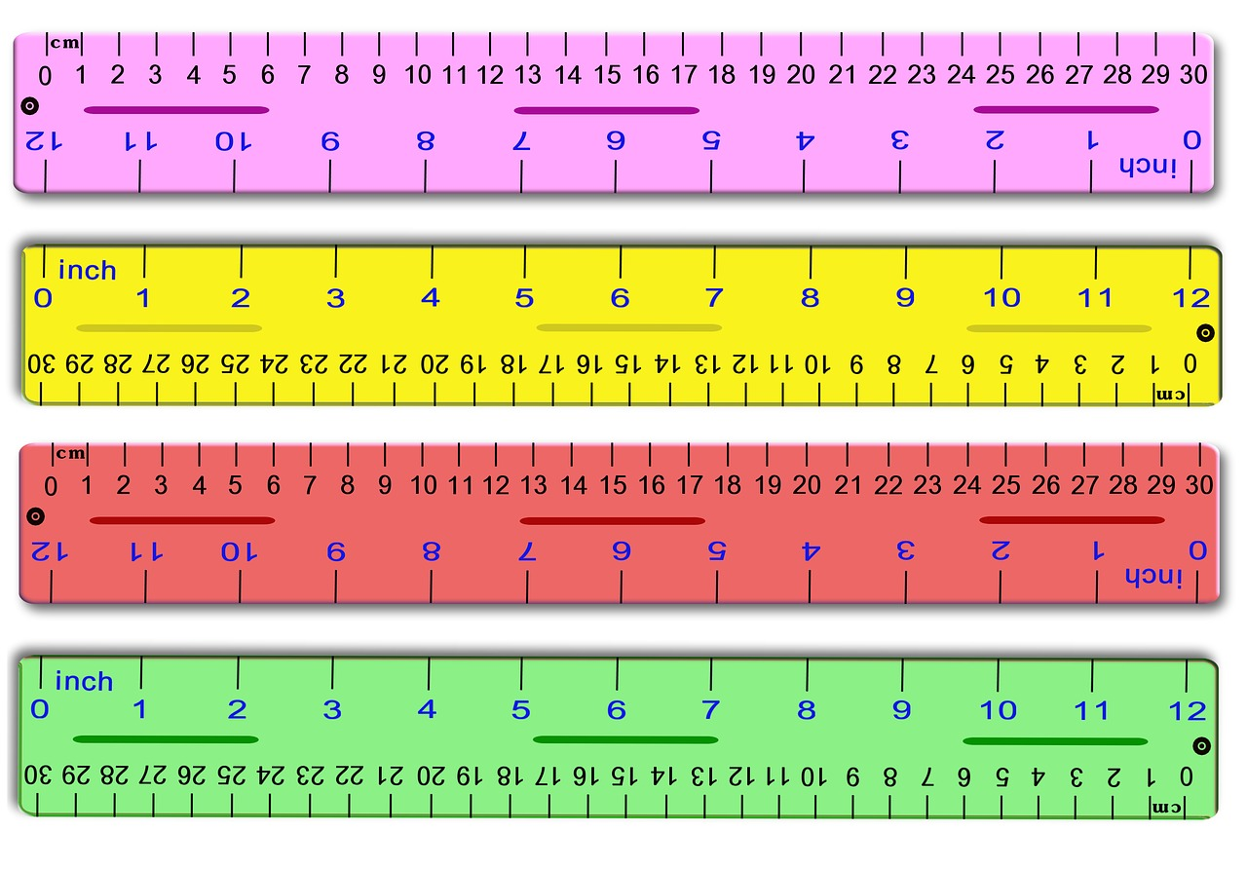

How many centimeters are in an inch?

(Between which centimeter values does 1 inch lie?)

____ cm to ____ cm

How many inches are in 10 centimeters?

(Between which inch values does 10 cm lie?)

____ in. to ____ in.

1. Examine the below the volumes in ounces and liters with the different containers



How many ounces are in 1 liter?

____ ounces = 1 liter

**Question 13 & 14 Examples**

The average weight of a fully assembled space shuttle is 4,500,000 pounds. What is the average weight of a space shuttle in kilograms?

<https://www.nasa.gov/centers/johnson/pdf/167751main_FS_SpaceShuttle508c.pdf>

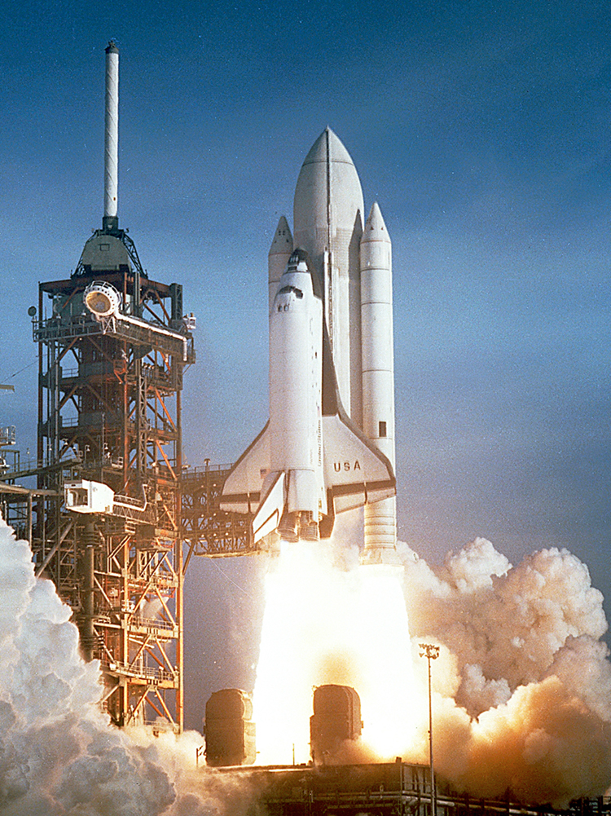

[This Photo](https://philschatz.com/physics-book/contents/m42166.html) by Unknown Author is licensed under [CC BY](https://creativecommons.org/licenses/by/3.0/)

1 lb = 0.45 kg

Let’s convert pounds to kilograms.



1. How much do you weigh in pounds (lbs)? (Write an estimate if you are not sure)

____ lbs

1. How much do you weight in kilograms (kg)? 1 pound = 0.45 kg

____ kg

CALCULATION SHEET

CALCULATION SHEET

CALCULATION SHEET

CALCULATION SHEET